**Software Requirement Specification(SRS):**

Login page:

* Admin login

* Managers login

* Employees login:

Teams:

1. Search Team
2. Abstract Team(**This team will do search part as well as Judgment parts**)
3. Judgment Team
4. Tax Team
5. OM Team
6. Copies Team

Note: **Team wise Save/Editing options only there respective sections**.

-----------------------------

Dash Board/Home:

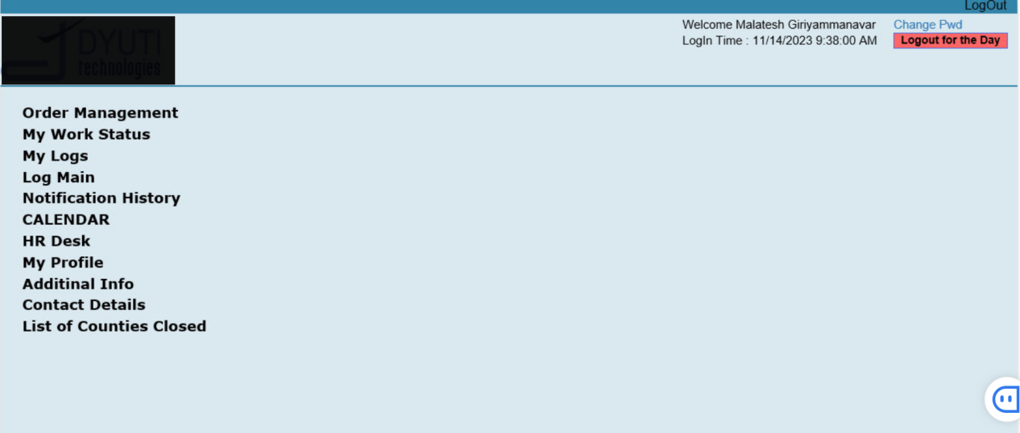

Welcome XYZ

Login Time: 04/16/2024 9:38:00 AM

GN2 Solutions

Note:

**Order Management:**

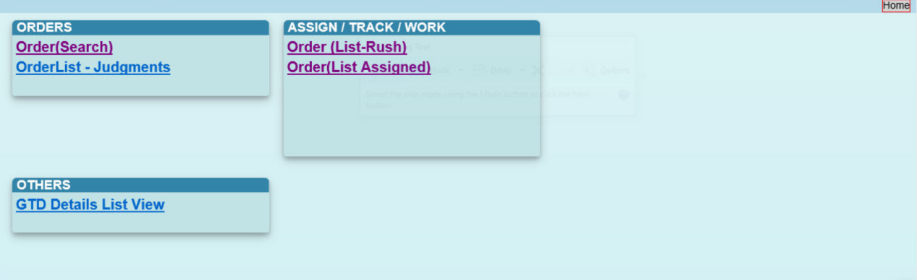

**My Work Status** :

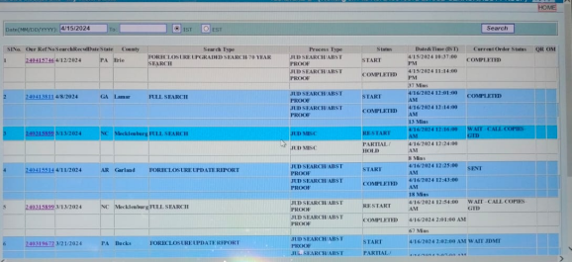

**My Logs:**

**Log Main:**

**Notification History:**

**CALENDAR:**

**HR Desk:**

**My Profile:**

**Additinal Info:**

**Contact Details:**

**Order(Search):**

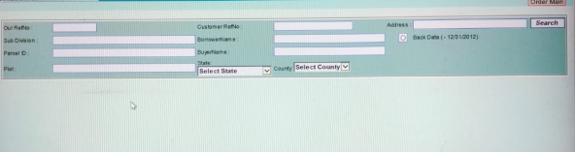

**Orders List :**

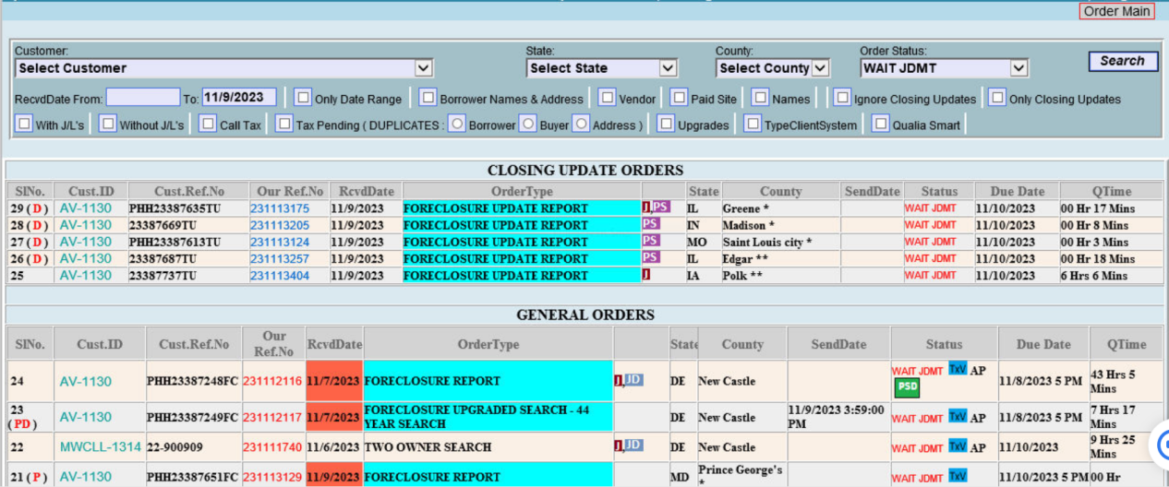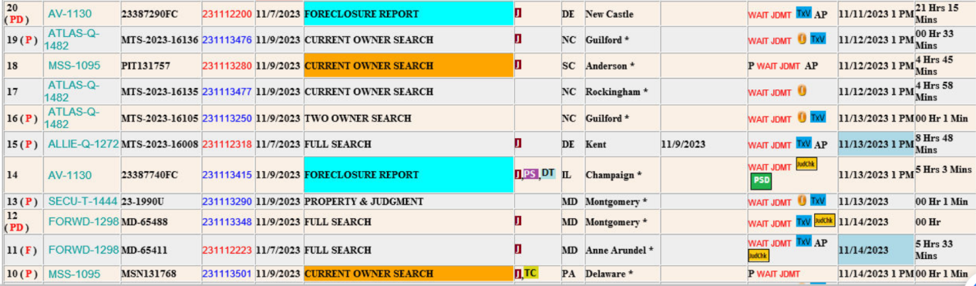

**Note: Orders Category's:**

1. **Closing update orders**
2. **Rush orders**
3. **General orders**

**Order (List Assigned):**



**Note: Assigned By XYZ Date:MM/DD/YY Time:00:00.00 AM/PM**

**====================================================================**

**Order Form:**

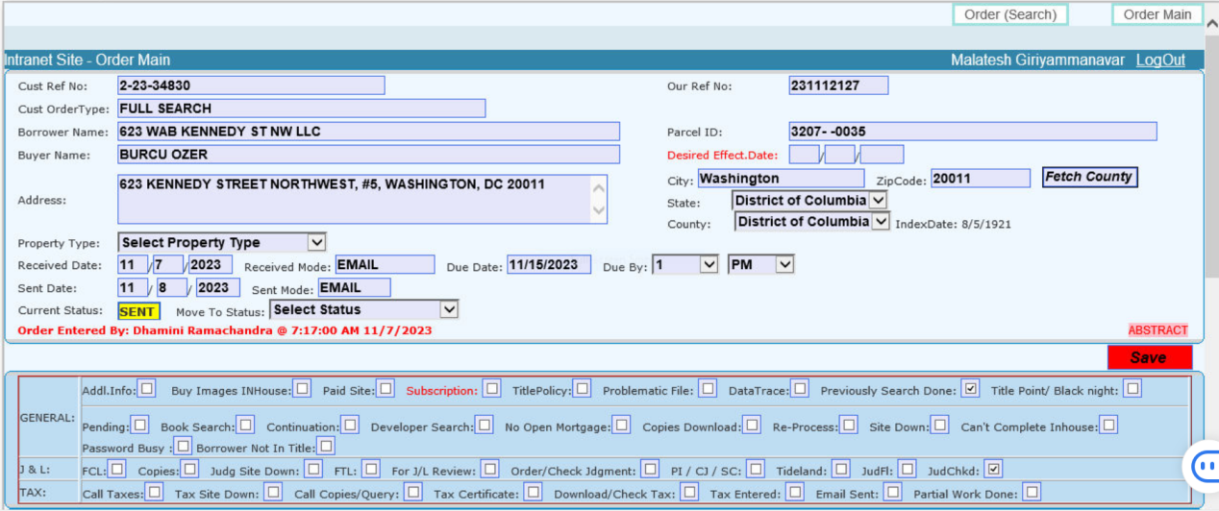

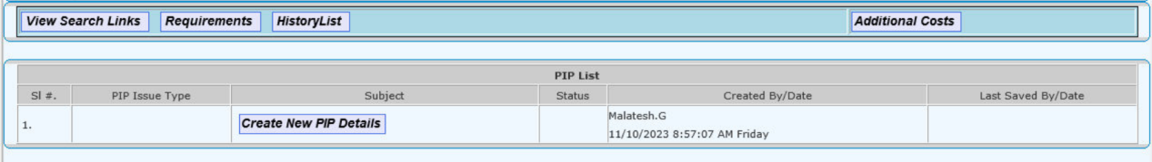

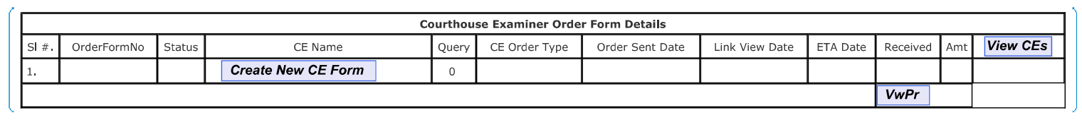

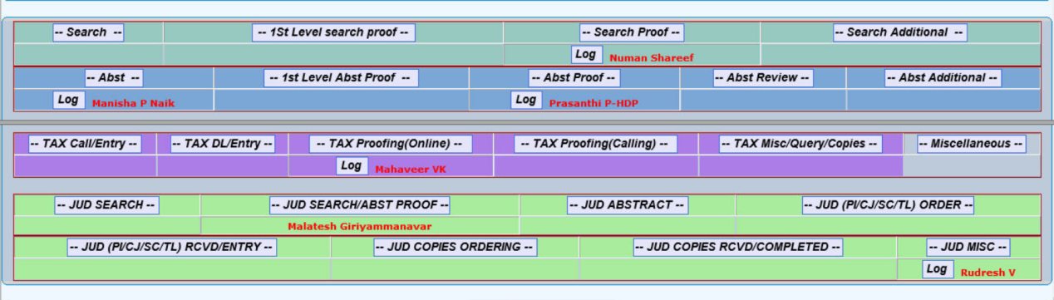

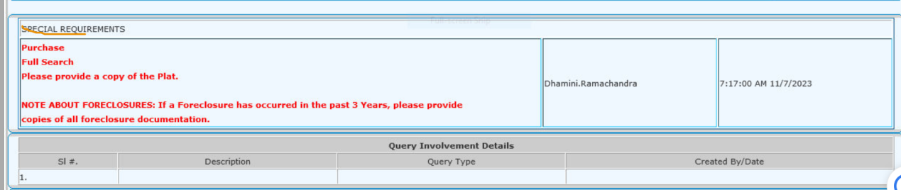

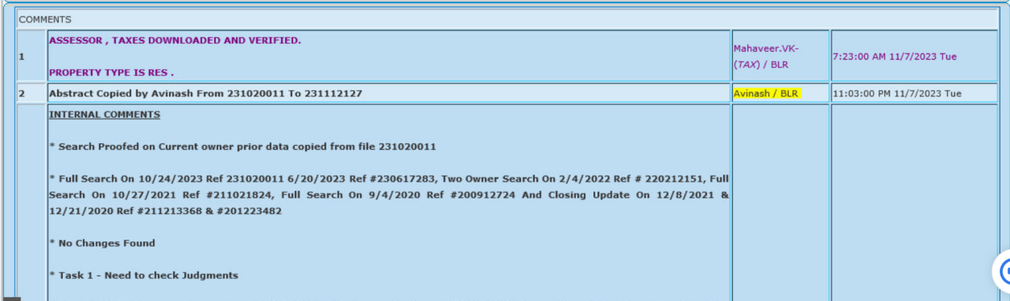

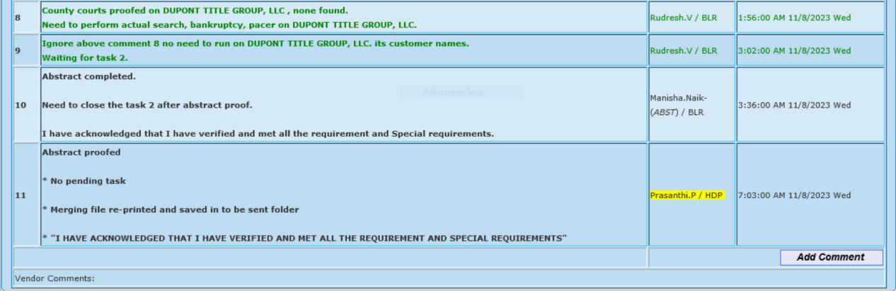

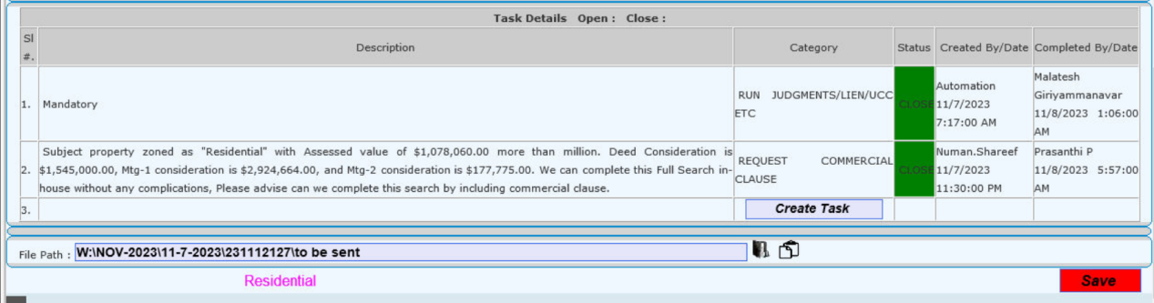

Note:

**OM Team Tab will Come (It will Display only to OM Team)**

**===================================================================================**

***View Search Links: \****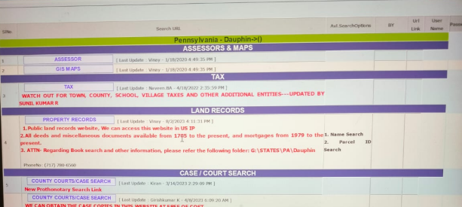

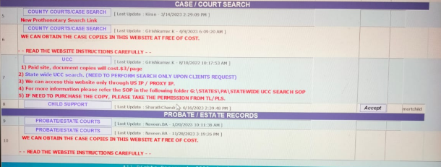

**Requirements:**

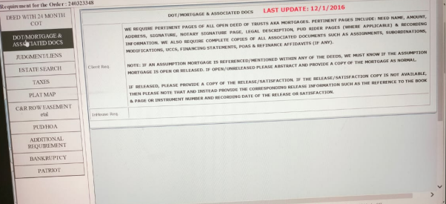

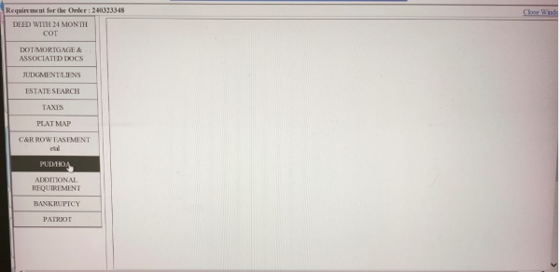

***History List: \****

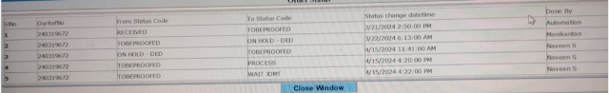

***Additional Costs:***

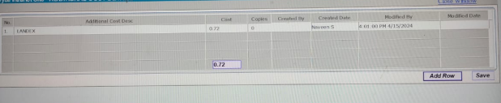

**ABSTRACT:**

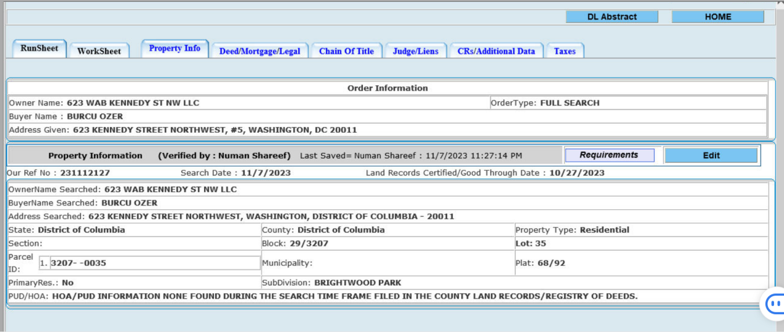

Note: **Before verification tab all tabs will be black colour and after verifying 6 Tabs then blue colour then only we are able to download the abstract.**

1. **Run Sheet:**

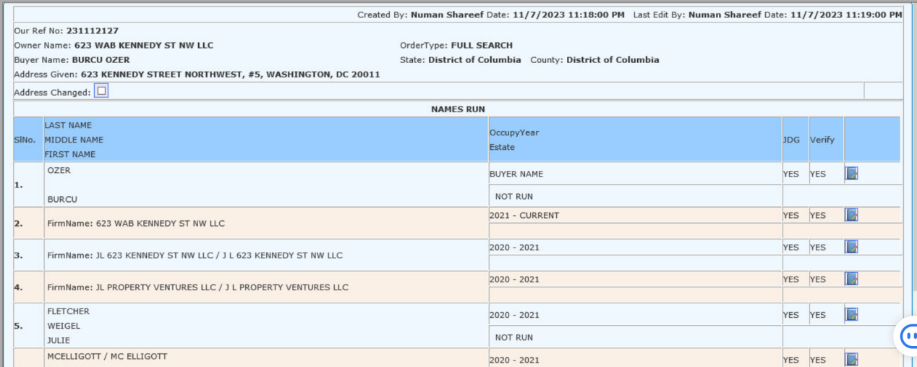

1. Work Sheet:

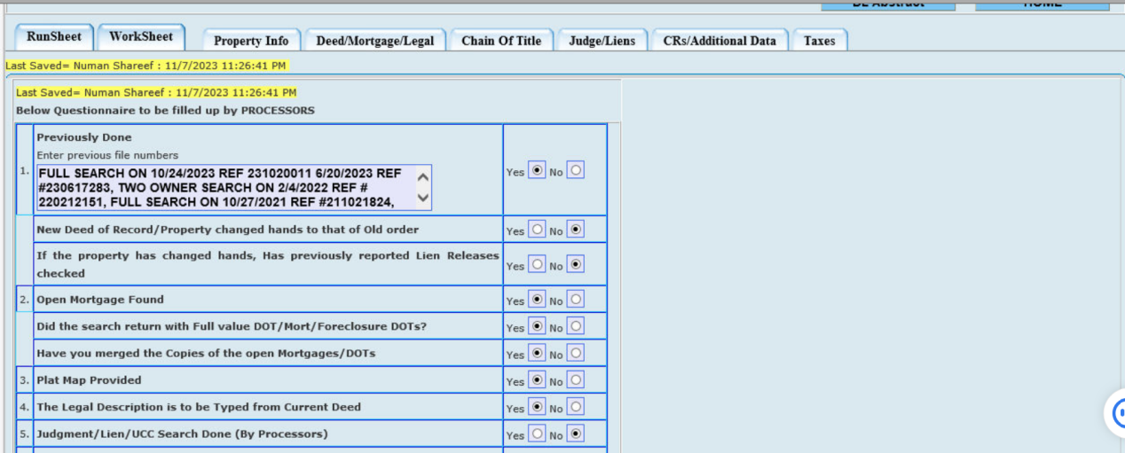

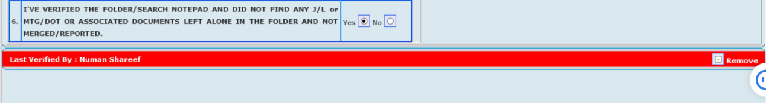

1. Property Info:

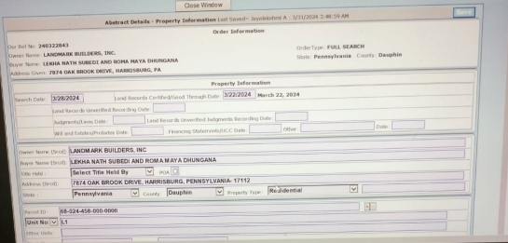

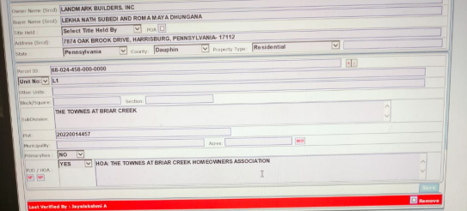

Note: After saved and Verified: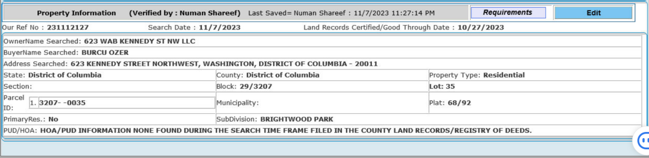

1. Deed/Mortgage/Legal:

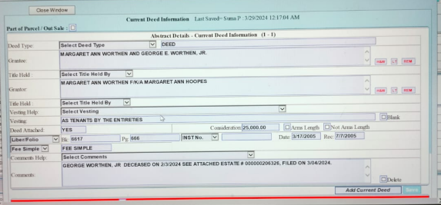

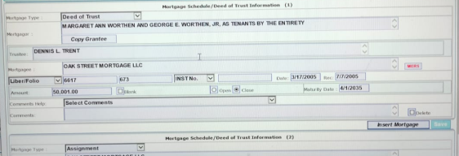

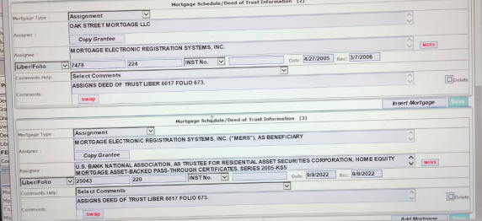

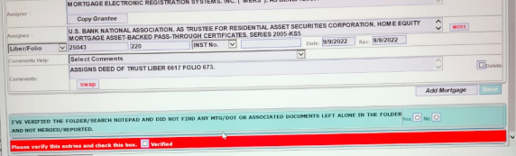

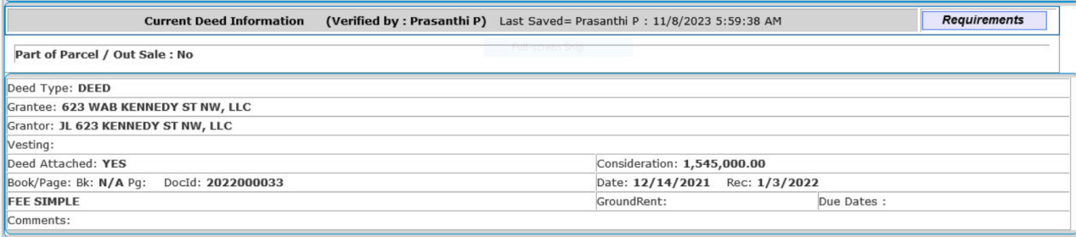

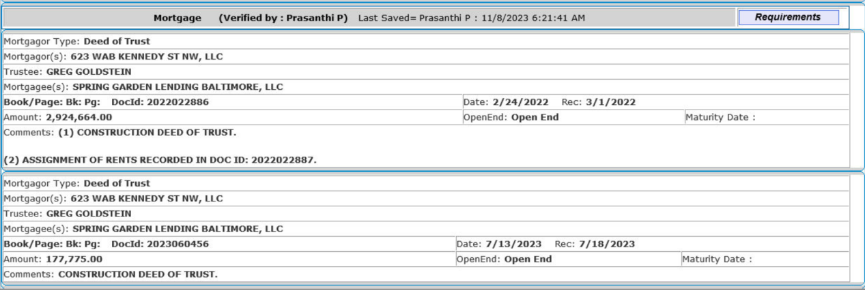

1. **Chain Of Title:**

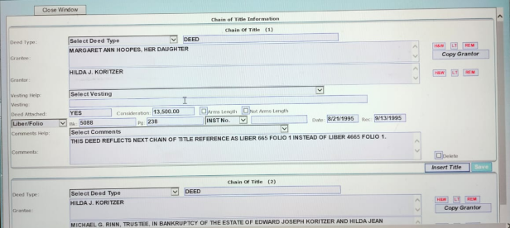

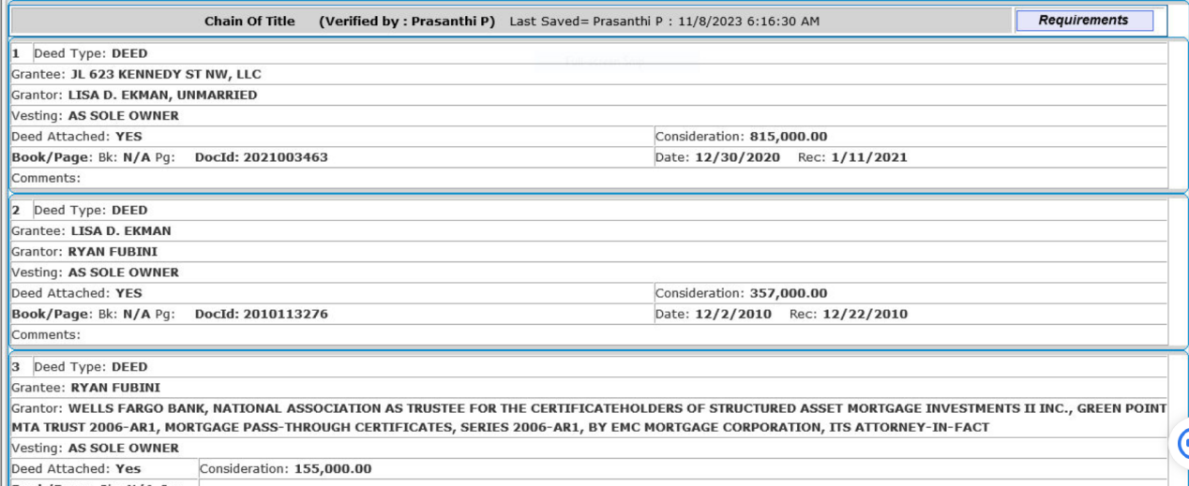



1. **Judge/Liens:**

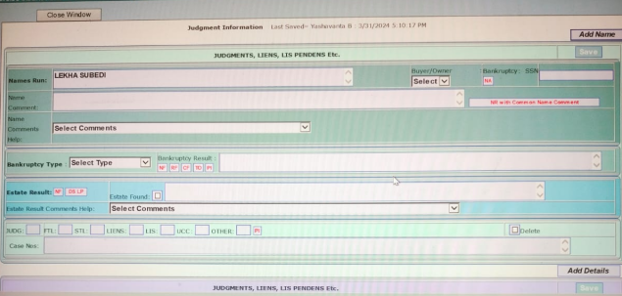

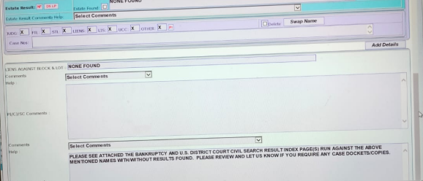

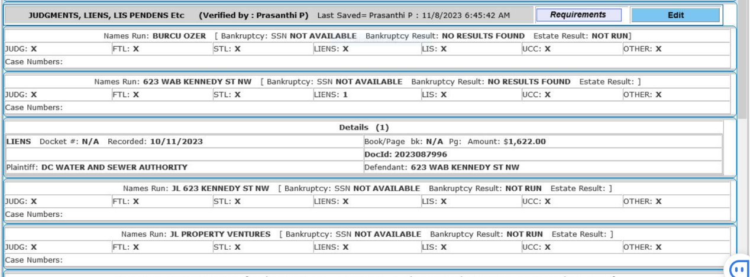

1. **CRs/Additional Data:**

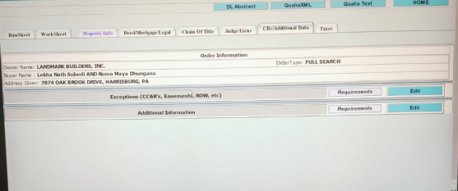

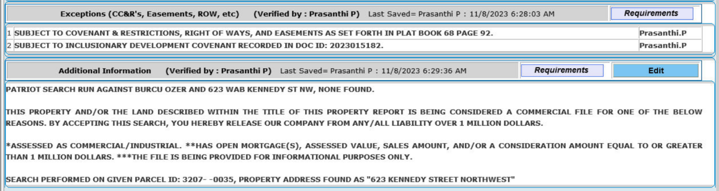

1. **Taxes:**

